# *Browser process - detailed architecture overview*

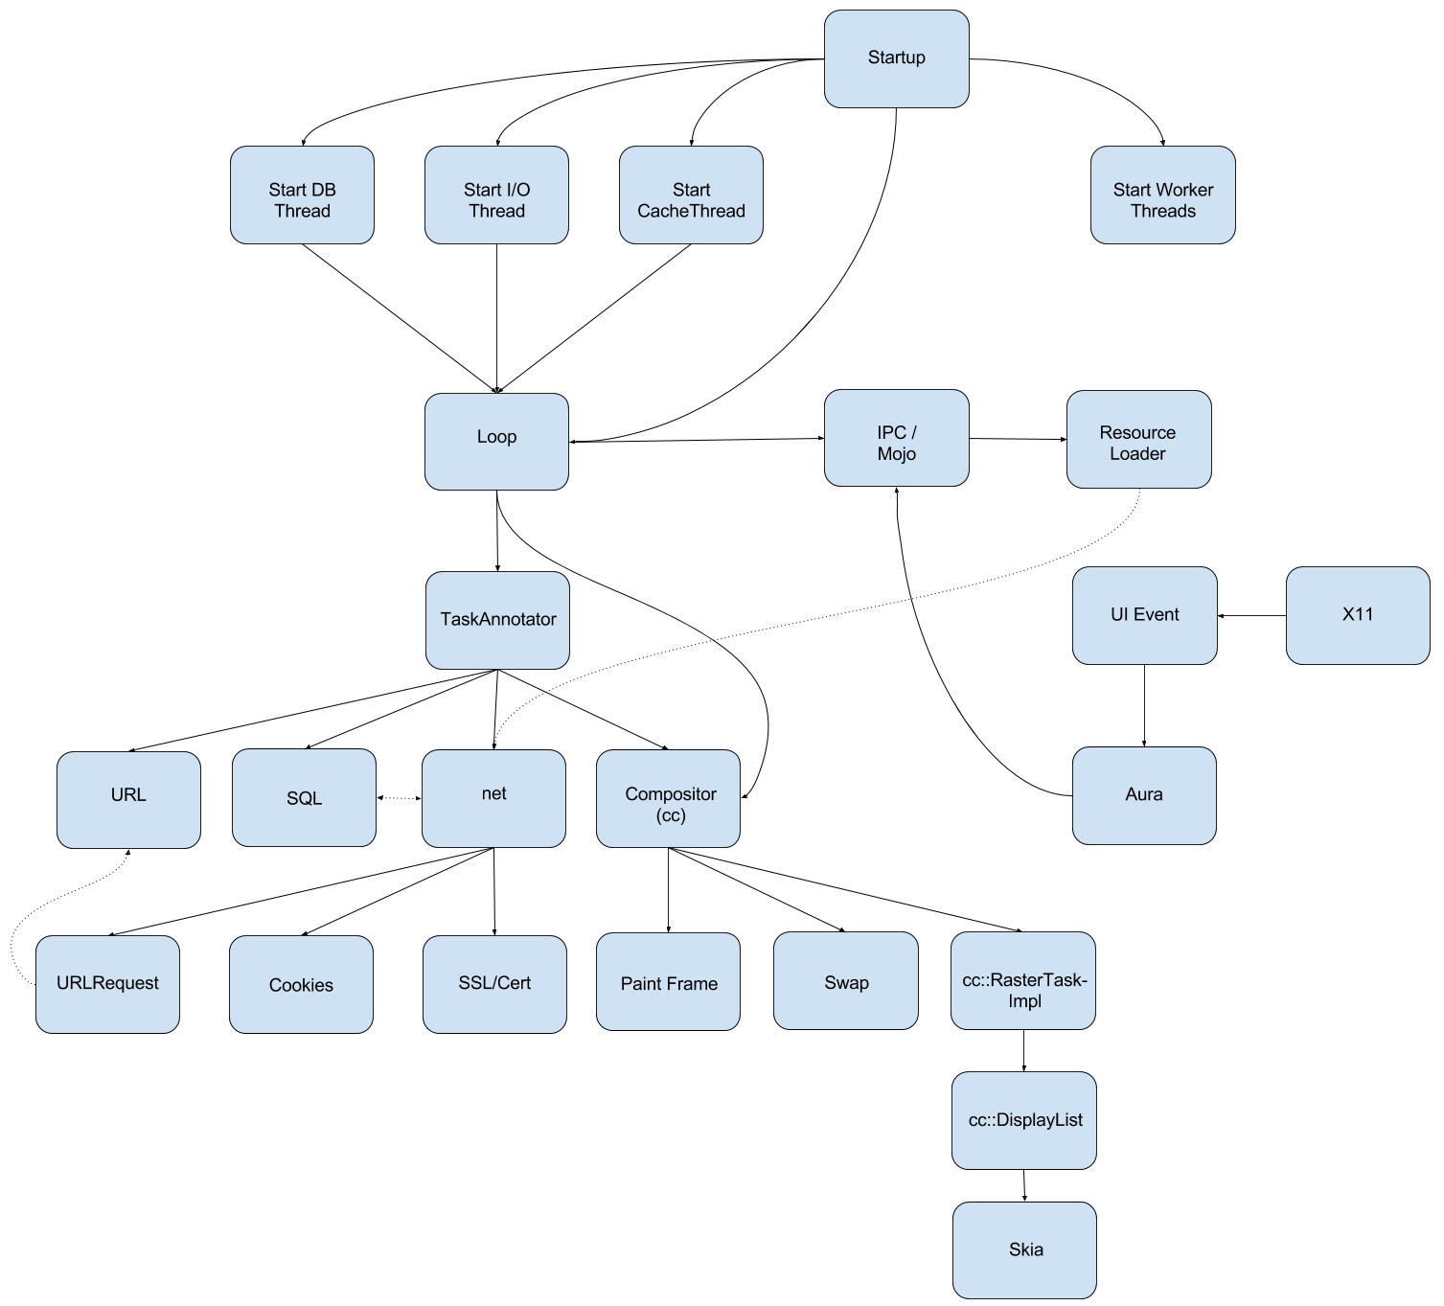

* **Startup**
  + This is the entry point of the whole application (Main).
  + Main launches ContentMain and BrowserMain
  + BrowserMain starts the MainMessageLoop
* **Threads**
  + Right after the startup the required threads are started
    - **I/O thread**
      * communication with the trenderer ask
    - **DB thread**
      * sqlite database connection and queries
    - **Cache thread**
      * cache store / retrieve
    - **Worker threads**
      * this is a facility that runs tasks that don't require a specific thread or a message loop
      * there is a thread pool called WorkerPool, which dynamically adds threads (if necessary) to handle all tasks
      * there are different implementations for POSIX and non-POSIX based systems
* **Loop**
  + MainMessageLoop
    - is used to process events for a particular thread
    - puts the incoming messages, tasks to a queue
    - pops a task from the queue and starts it
    - strong relationship with the IPC communication framework
    - has task reentrancy protection
      * second task cannot be started until first task finishes
* **IPC / Mojo**
  + framework which is used for inter-process communication
  + connects directly to the MainMessageLoop
  + provides communication channels through which the messages can be sent
  + message creating, sending and receiving
  + asynchronous message handling
* **TaskAnnotator**
  + all incoming tasks are going through a TaskAnnotator which annotates the task before the execution
  + implements common debug annotations for posted tasks. This includes data such as task origins, queueing durations and memory usage
  + runs a previously queued task
* **ResourceLoader**
  + browser side of the resource dispatcher
  + receives requests from the child processes (Renderer, Worker, etc)
  + dispatches the received requests to URLRequests
  + forwards the messages from the URLRequests back to the correct process for handling
* **URL**
  + this group contains all the URL-relevant features
  + URL replacing and URL extension
  + URL autocomplete
  + extracting search terms from URL
  + URL parsing
  + URL canonicalization (picking the best URL, when there are multiple choices)
  + connection to **Omnibox** (Chromium’s “smart” URL bar)
* **SQL**
  + classes which communicate with the sqlite3 database
  + load / update url autocomplete predictions from database
  + load saved favicons
* **net**
  + NetworkDelegate
    - performs actions before the **URLRequest** starts
  + starts **URLRequests**
  + handles **Cookies**
    - loads all Cookies for a given URL async
    - sets all Cookies for the given URL
  + **SSL Cert**
    - handles SSL related actions
    - SSL handshake
    - certification verifying
      * signature verifying
* **Compositor (cc)**
  + **PaintFrame**
    - painting main frame
    - prepare tiles
    - update layers
    - update picture layer
    - update display list
    - paint to display list
    - Aura’s painting is called
      * paint Tabs
  + **Swap**
    - draw to a specified surface
    - swap buffers
  + **RasterTask**
    - task, which performs rasterization
    - tasks are represented as a task graph
      * edges: dependencies
      * node: tasks, priority is assigned to them
    - items in the display list are drawn to the surface
    - the rasterization calls specific **Skia** functions in order to get the canvas drawn correctly
      * drawColor, drawPicture, drawRect, fillRect, etc.
* **X11/Windows/Mac**
  + captures mouse, key, (etc) events and passes it to Chromium
* **UIEvent**
  + classes in **views** and **ui** namespaces deal with all UI related functionalities
  + one of their important duties is handling UI events, for example mousemove, mouseclick, keypress, etc.
  + these events are passed forward from the system's Windowing library
  + the events are passed through an event handling chain in order to perform certain actions in each step
  + if the user enters the URL into the URLBar, these classes perform the character insertion into the URLBar’s text field.
  + **Aura**
    - UI framework, desktop window manager and shell environment
    - cross platform
    - Chrome OS uses it as well as Chrome / Chromium
    - Aura provides Window and Event types, as well as a set of interfaces to customize their behavior

*Sources:*

<https://www.chromium.org/developers/design-documents/aura/aura-overview>

<https://code.google.com/p/chromium/codesearch#chromium/src/base/threading/worker_pool_posix.h>

<https://code.google.com/p/chromium/codesearch#chromium/src/base/message_loop/message_loop.h>

<https://code.google.com/p/chromium/codesearch#chromium/src/content/browser/loader/resource_dispatcher_host_impl.h>

<https://www.mattcutts.com/blog/seo-advice-url-canonicalization/>

<https://code.google.com/p/chromium/codesearch#chromium/src/base/debug/task_annotator.h&q=task_annotator&sq=package:chromium&type=cs&l=1>

<https://code.google.com/p/chromium/codesearch#chromium/src/cc/raster/task_graph_runner.h&q=taskgraph&sq=package:chromium&type=cs&l=42>

<https://code.google.com/p/chromium/codesearch#chromium/src/base/threading/worker_pool.h&q=worker_pool.h&sq=package:chromium&l=1>